**HBASE ASSIGNMENT 2 – Python API**

Access all the tables created in Assignment 1 and run those queries through the python API

Two tables created in Hbase assignment 1

1. **Indhudb: SSbyvarioususer**
2. **Indhudb:Album**

**Table 1 Results**

import happybase

connection = happybase.Connection('10.1.1.204', 9090)

table = connection.table('indhudb:ssbyvarioususer')

for key, data in table.scan():

print(key,data)

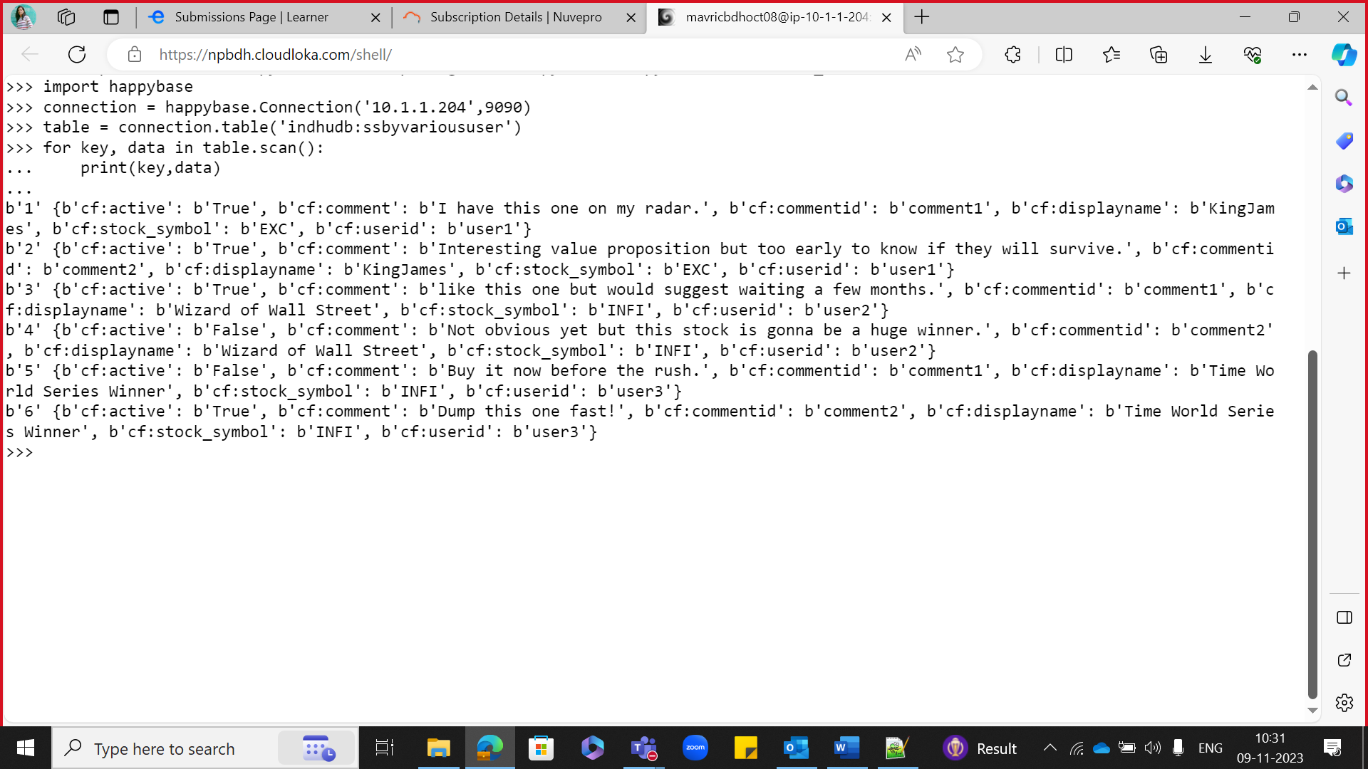

1.row = table.row(b'1')

print(row[b'cf:comment'])

2.for key, data in table.scan(filter="SingleColumnValueFilter('cf','userid',=,'substring:user3')"):

print(key,data)

3.for key, data in table.scan(filter="SingleColumnValueFilter('cf','active',=,'substring:False')"):

print(key,data)

**Table 2 Results:**

import happybase

connection = happybase.Connection('10.1.1.204', 9090)

table = connection.table('indhudb:Album')

for key, data in table.scan():

print(key,data)

1.for key, data in table.scan(filter="SingleColumnValueFilter('info','singer',=,'substring:Singer2')"):

print(key,data)

2.for key, data in table.scan(filter="SingleColumnValueFilter('info','musicdirector',=,'substring:AK')"):

print(key,data)2

**Task 2**

Also Create new tables from python and insert some data in to those tables

import happybase

connection = happybase.Connection('10.1.1.204',9090,table_prefix='indhudb'))

connection.create_table(

'Employee',

{'info1': dict(max_versions=10),

'info2': dict(max_versions=1, block_cache_enabled=False),

'info3': dict(), # use defaults

}

)

print(connection.tables())

table = connection.table('Employee')

for i in range(15):

table.put(b'rowkey-%d'%(i), {b'info1:name': b'emp-%d'%(i),b'info2:city': b'%d'%(i)})

for key, data in table.scan():

print(key, data)

**OUTPUT:**

b'rowkey-0' {b'info1:name': b'emp-0', b'info2:city': b'0'}

b'rowkey-1' {b'info1:name': b'emp-1', b'info2:city': b'1'}

b'rowkey-10' {b'info1:name': b'emp-10', b'info2:city': b'10'}

b'rowkey-11' {b'info1:name': b'emp-11', b'info2:city': b'11'}

b'rowkey-12' {b'info1:name': b'emp-12', b'info2:city': b'12'}

b'rowkey-13' {b'info1:name': b'emp-13', b'info2:city': b'13'}

b'rowkey-14' {b'info1:name': b'emp-14', b'info2:city': b'14'}

b'rowkey-2' {b'info1:name': b'emp-2', b'info2:city': b'2'}

b'rowkey-3' {b'info1:name': b'emp-3', b'info2:city': b'3'}

b'rowkey-4' {b'info1:name': b'emp-4', b'info2:city': b'4'}

b'rowkey-5' {b'info1:name': b'emp-5', b'info2:city': b'5'}

b'rowkey-6' {b'info1:name': b'emp-6', b'info2:city': b'6'}

b'rowkey-7' {b'info1:name': b'emp-7', b'info2:city': b'7'}

b'rowkey-8' {b'info1:name': b'emp-8', b'info2:city': b'8'}

b'rowkey-9' {b'info1:name': b'emp-9', b'info2:city': b'9'}

